**Sharepoint Migration to Office 365 using Azure Storage**

**Introduction and Prerequisites**

Remember that planning for any Office 365 migration is the most critical part of a migration. This Sharepoint migration method works efficiently (assuming you’re going to use Azure for cloud hosting services), it’s free and it doesn’t require any 3rd party software, but it doesn’t have any logging. Here are some pre-requisites that you must take care of while migrating data from SharePoint to SharePoint Online via Azure Storage.

1. Create an Azure Storage resource.

2. Install SharePoint Online Management Shell version 16.0.4017.1200 or above.

3. Install SharePoint PowerShell 4.0 prior to the Online Management Shell.

**SharePoint 2010 to SharePoint Online Migration Steps:**

**Step 1. Export the data from the SharePoint 2010 environment using Export-SPWeb.**

1. Go to the start menu, and run the SharePoint 2010 Management Shell as Administrator.
2. Run the below command:

Export-SPWeb -Identity “http://<On-PremSPSite>” -ItemUrl “/OnPremDocLib” -Path “C:\SPOnPremExport” -NoFileCompression -IncludeVersions 4

(Replace the Web URL and the Document Library with your own URL and Library name)

1. After completing it successfully, you will see that a folder has been created with the contents shown below:

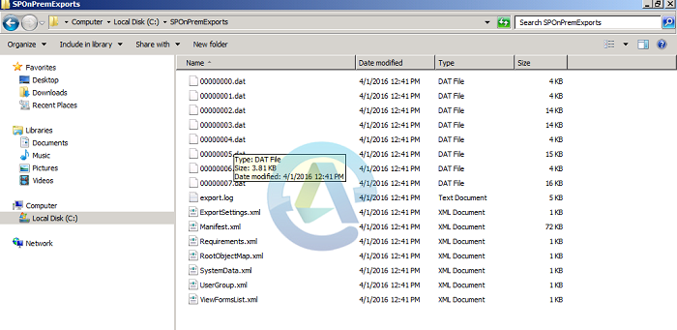

1. Create the missing file LookupListMap.XML manually by in the above exported folder with the name: LookupListMap.xml. With the following contents in the file

<?xml version=”1.0″ encoding=”utf-8″?>

< LookupLists xmlns=”urn:deployment-lookuplistmap-schema”/>

**Step 2 - Convert the Exported package to the SPO Migration Package using the SharePoint Online Management Shell.** (On the machine that you’re going to run the Sharepoint Online Management shell)

1. Copy contents of the export folder to a new path:

“C:\migrationpackages\SPOTemp”.

1. Then, run SharePoint Online Management Shell as Administrator.
2. First Cache your credentials by entering

$credential=get-credential (login with global admin rights)

1. Then connect to SharePoint Online by running

Connect-SPOService -URL https://<TENANT>-admin.sharepoint.com -credential $credential

1. Convert Packages by running:

ConvertTo-SPOMigrationTargetedPackage

-SourceFilesPath “C:\SPOnPremExports”

-SourcePackagePath “C:\SPOnPremExports”

-TargetDocumentLibraryPath “Shared Documents”

-TargetWebUrl https://<YourTenant>.sharepoint.com

-OutputPackagePath c:\migrationpackages\SPOutPutPackage

(This will create the SPOutPutPackage folder with packages)

**Step 3. Upload the SPO Migration Package to your Azure Storage account.**

If you haven’t provisioned Azure storage here’s how:

1. Login to the Azure Portal: [Https://portal.azure.com](https://portal.azure.com)
2. Go to storage -->create new storage account and give it an appropriate name
3. In the newly created storage account create 2 containers migration-files, migration-package
4. Enter the following in PowerShell

$azurelocations = Set-SPOMigrationPackageAzureSource

-SourceFilesPath “C:\MigrationPackages\SPOTEMP”

-SourcePackagePath “C:\MigrationPackages\SPOutPutPackage”

-FileContainerName migration-files

-PackageContainerName migration-package

-AccountName “yourstoragestorage”

-AccountKey “AZURE STORAGE KEY”

**Step 4. Submit the Migration Job.**

Submit the job by entering the following command:

Submit-SPOMigrationJob -TargetWebUrl https://yourtenant.sharepoint.com/ -MigrationPackageAzureLocations $azurelocations

**Step 5. Check Migration Job Status**

There are 2 ways of checking the status of the migration job.

1. If you’re logged onto Office 365 refresh your document library
2. In powershell run:

Get-SPOMigrationJobStatus -TargetWebUrl https://<SPOSite>.sharepoint.com

Below are the definitions of the results that returns

* Queue Status: Data been not picked to process. Wait sometime to go under process.
* Processing Status: Data will processing from Azure to tenant site.
* No Status: If job is successfully completed then it will not show any status.

**Step 6 (Optional) - Remove Migration Job**

In case if the migration job is stuck or if it needs to be removed for any reason you could use the below command (This will work only if the job is not already completed)

* Remove-SPOMigrationJob -”YourJobID” -TargetWebUrl https://sharepoint.sharepoint.com